Kimberly DeSimone
October 26, 2016
Journal 1: Leaders Need to Walk the Talk

One of the overriding themes that continues to emerge in class is the “hard work” of diversity and inclusion. Many companies tout the value of diversity and inclusion but then fail to implement and support policies and practices aimed at increasing diversity within the organization. They don’t give employees the tools they need to not only increase diversity, but to retain diversity and create an inclusive environment conducive to the success of those in the majority. In short, organizations to often fail to walk the talk. In considering my research interests related to the barriers and obstacles that hinder women, the hard work of diversity is of paramount importance. The concept of walking the talk is crucial in moving family-friendly and work-life-balance initiatives from theoretical policies to pragmatic practices which serve to support women’s organizational success. Many organizations have implemented a host of programs for employees related to career development and planning, training and mentoring, and talent management. Often these initiatives are viewed as a panacea for lack of diversity when there are deep-rooted hegemony issues that are not easily solved.
Programs aren’t worthwhile if they don’t result in positive change for employees as it relates to power (and who has it). It is programs combined with tangible outcomes such as increased numbers of top earners and high level executives emerging from diverse and frequently marginalized groups that prove whether or not an organization is able to model the way or walk the talk as Kouzes and Posner (2012) suggest. Challenging existing processes that have failed to move the needle for minorities and women at the highest levels is needed. As Kouzes and (2012) Posner espouse “Change is the work of leaders. It’s no longer business as usual and exemplary leaders know that they have to transform the way things are done” (p. 158). Historically, business as usual has worked for maintaining men at the highest levels of leadership in corporate organizations. As such, we need both men and the few women in leadership roles to take seriously Kouzes and Posner’s (2012) advice to challenge the process as it relates to retaining top female talent and in “exercising outsight” in searching for opportunities to “get extraordinary things done” (p. 159).
As organizational leaders, our attitudes and behaviors related to diversity and inclusion are crucial. This is in part why there was so much public controversy and criticism when Yahoo Chief Executive Officer (CEO) Marissa Mayer announced that she would be taking two weeks of maternity leave and working throughout that truncated maternity leave after the birth of her twins. Mayer had been responsible for implementing family-friendly policies such as doubling Yahoo’s maternity leave from eight to 16 weeks of paid time off. The controversy and criticism that emerged regarding her public position on her maternity leave was relative to Mayer’s position as a role model within women’s advanced leadership. As a high profile leader, everyone is watching her behavior and her choices which are seen as more than a women’s personal choice because of the potential impact and precedent resulting from the behavior. If as research shows maternity leave policies are correlated with an increase in women remaining in the workforce (Whitmarsh, Brown, Cooper, Hawkins-Rodgers, & Wentworth, 2007), then to have a workforce inclusive of women in top leadership roles, maternity policies must not only be implemented, but as the Essentials of Diversity PowerPoint which indicates the diversity skills/diversity awareness axis, organizations need to move from an equal opportunities policy mindset towards accepting and valuing diversity to achieve inclusion and diversity goals. This includes attitudes towards maternity leave, women with children, and overall work-life-balance initiatives. Williams and Dempsey (2012) explain that when women have children “they can find themselves suddenly shunted from the career woman category into the mother category, leading to a ramping up of negative competence and commitment assumptions” (p. 135).
Diagram 1. Diversity skills and awareness goals. PowerPoint Presentation (slide 18) from October 20, 2016 Diversity class. Presented by Dr. Hahn.
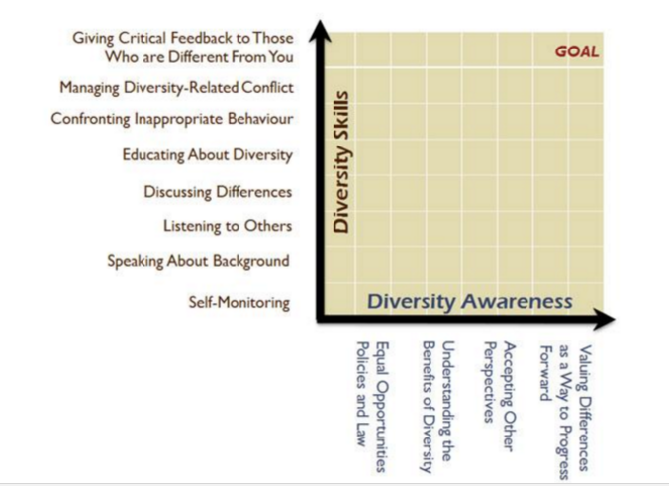
Mayer’s decision to return to work so quickly and so publicly abbreviate her maternity leave is a challenging one to consider. While I, like many women, are hesitant to call out other women’s choices, I can’t feeling a sense of dismay when I consider the powerful example leaders set through their actions, and how that influences the attitudes and behaviors of others. This is why there was a level of frustration with Mayer’s choice. Anne Weisberg, senior vice-president of the Families and Work Institute in New York expressed her disappointment with Mayer’s decision in a September 2015 interview with the Guardian asserting “She’s a role model and I think she should take whatever Yahoo’s parental leave is—the mark of a great leader is that they have a strong team and don’t need to be there all the time themselves.” In this example, it can be argued that the values Mayer is living are not aligned with her stated vision and policies. Not only do her actions suggest that in spite of the increased benefits she has implemented as CEO, in practice, women don’t need the time, but on a larger scale this choice affects every person’s morale in the company as it suggests that they can’t be successful or fully productive without Mayer. How demoralizing that message must be to both the men and women who support Yahoo’s initiatives and Mayer’s vision.
How leaders behave is often much more powerful than corporate policies. As such, the way leaders handle work-life-balance initiatives is hugely symbolic and influential. Leaders set the example or the standards for their organizations and often, their industries. This is especially true for women who at the highest levels are so underrepresented. If female leaders don’t walk the talk when it comes to parental leave, even the lowest-ranked employee in the field will feel those repercussions in the form of expectations and criticisms. Living our values is very powerful. When we live our values (rather than espouse policies), we let people know that they can make similar life choices and that those choices will be respected rather than judged. This is very empowering. Hip-hop mogul and author Russell Simmons (2014) espouses the value of life balance in his company, but then goes further to model the way and walk the talk, by putting his daily yoga classes on his public schedule and letting everyone know that there is no appointment or urgent business issue that he is willing to cancel his yoga class for. This models his vision of work-life balance in a very tangible way which allows others to make similar choices without fear of stigmas or unspoken repercussions. Ralph Waldo Emerson said “who you are speaks so loudly I can’t hear what you’re saying”. So here’s the challenge to all leaders reading this post. Let’s go out and set the tone. Let’s be sure to walk the talk.
Reference
Kouzes, J. M., and Posner, B. Z., (2012). The leadership challenge: How to make extraordinary things happen in organizations (5th ed.). San Francisco, CA: Jossey-Bass.
Simmons, R., & Morrow, C. (2014). Success through stillness: Meditation made simple. New
York, New York: Gotham Books.
Walters, J. (2015, Sept). Yahoo CEO Marissa Mayer's minimal maternity leave plan prompts dismay. The Guardian. Retrieved April 1, 2016 from https://www.theguardian.com/technology/2015/sep/02/yahoo-ceo-marissa-mayer-minimal-maternity-leave-plan-prompts-dismay
Whitmarsh, L., Brown, D., Cooper, J., Hawkins-Rodgers, Y., & Wentworth, D. (2007). Choices and challenges: A qualitative exploration of professional women's career patterns. Career Development Quarterly, 55(3), 225-236.
Williams, J.C. and Dempsey, R. (2014). What works for women at work: Four patterns working women need to know. New York, NY: New York
University Press.

